Our ref PQ/HD/65764 3 October 2016

Dear Parent/Guardian

I am writing to confirm that we have a teacher training day on Friday 7 October. The school will be closed to students on that day. We have one other training day this academic year and that is on Monday 24 April 2017.

All of our holiday and training days are on our website both for this academic year and 2017/18.

Yours faithfully

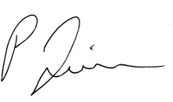

MR P QUINN
Headteacher

