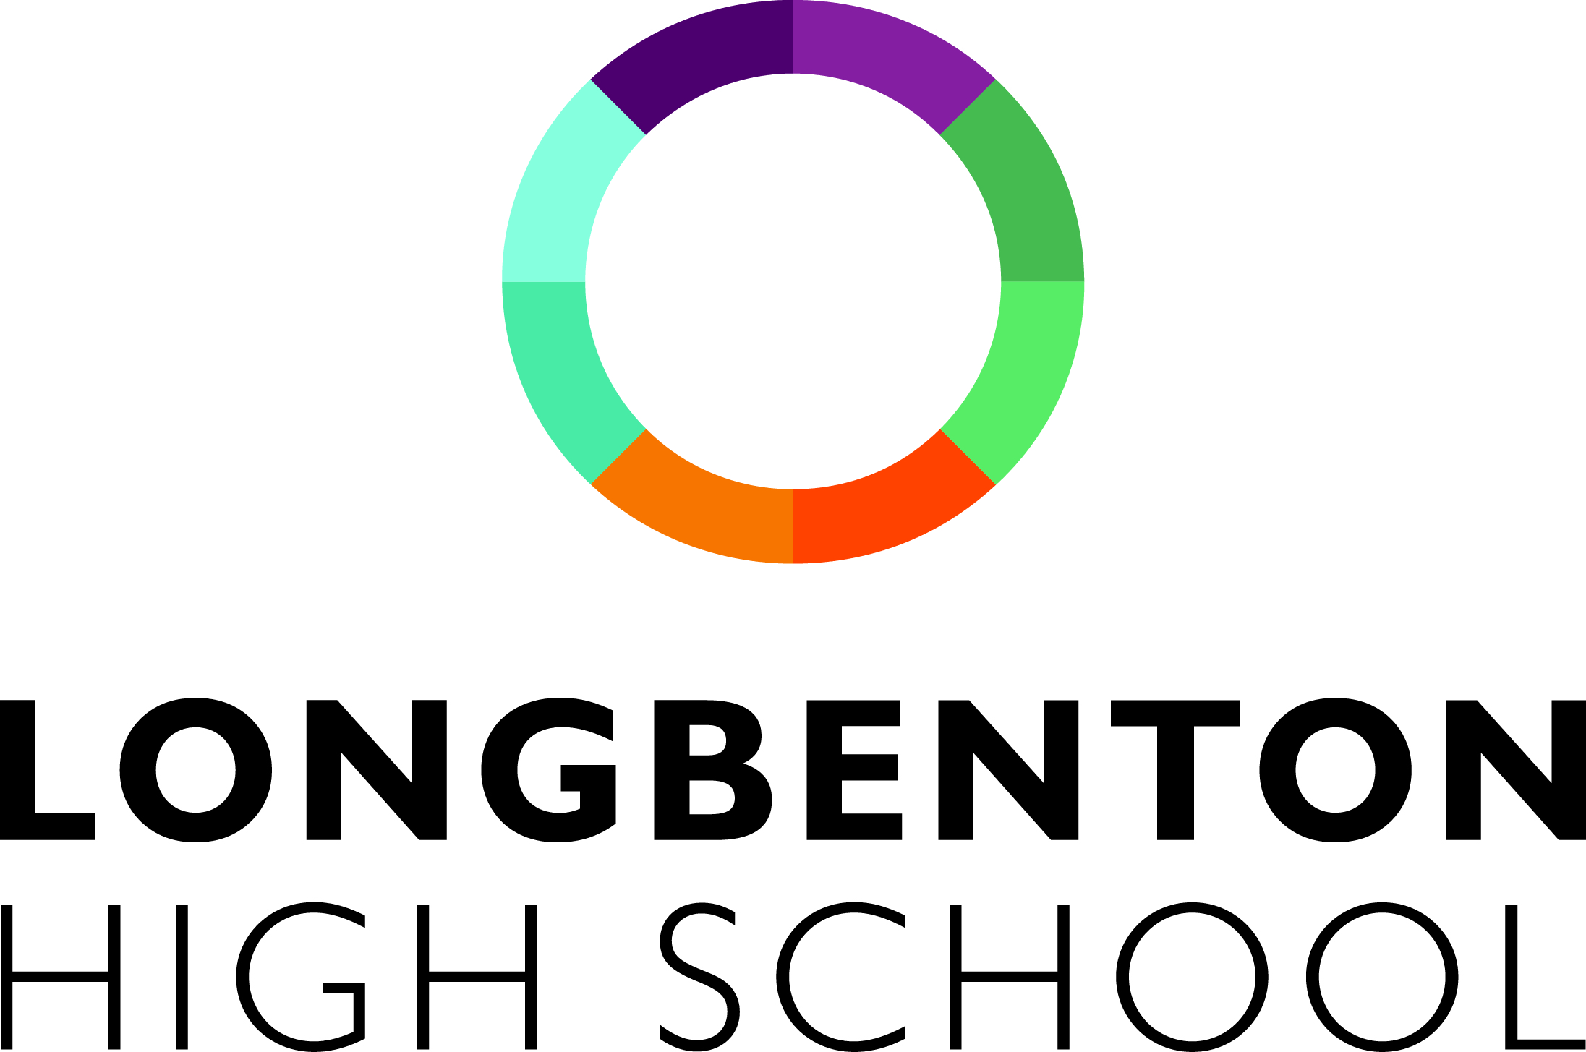

**YEAR 9 INFORMED CHOICES**

Year 9 students are coming to the end of their time in Key Stage 3 and it is important that we start to make arrangements for their entry into Key Stage 4.

One change to the students’ work in Years 10 and 11 is that they have a greater choice of subjects than they had in Year 9. This is because the examinations at the end of Year 11, which are mainly the General Certificate of Secondary Education, require more teaching time for subjects than was given in Key Stage 3.

All students will study English Language and English Literature, Maths and Science (with two GCSE’s). In addition, everyone will take RSD and Core PE. However, the other subjects are optional. We do, though, insist that all students choose at least one of History, Geography, French or Spanish to ensure a broad and balanced curriculum within the option choices.

**The English Baccalaureate** (please note this is not a separate qualification).

This is a classification by the government of a set of subjects that are being held up as a desired ‘academic’ collection of qualifications. At Longbenton this includes English, Maths, Science (worth two GCSEs), a humanities subject (either Geography or History) and a modern foreign language (either French or Spanish).

All students should think carefully about their choices and include a balance of what they enjoy, what they are good at and what might be useful for a future career.

There are some key dates in this process that it will be useful for you to note:

**Monday 26 February** Parents’ Evening for Year 9 with the opportunity for parents to have any questions or concerns answered

**By end of Thursday 29 March** All Year 9 students to have had a one-to-one interview about their option choices with Mrs Cooper, Mrs Holbrook or Mr Quinn.

We shall do our best to provide the subjects for which students opt. It must be said, however, that if too few students opt for a particular subject, we will require some students to change their choices as we cannot afford to sustain small groups.

We do expect that this whole process will work effectively and that students can embark on the Key Stage 4 curriculum with confidence and achieve excellent results. If you have any questions or concerns please contact Mrs Cooper, Year Leader for Year 9.

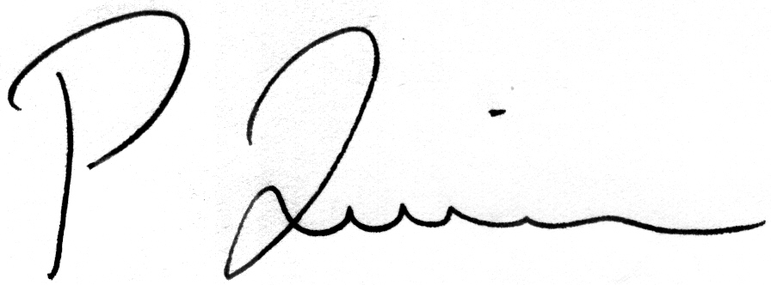

**P QUINN**

Headteacher

**ENGLISH LANGUAGE**

**ENGLISH LITERATURE**

The English courses in Years 10 and 11 lead to qualifications in English Language and English Literature and all students will study both to GCSE. Both courses follow the AQA specification; students will be awarded grades 9-1 (with 9 being the highest). There are no separate tiered papers and all examinations will be taken in Year 11.

In English Language students will study a range of fiction and non-fiction texts from the 19th, 20th and 21st Centuries. They will analyse the techniques that writers use to communicate information and ideas whilst developing their own written skills.

In English Literature students will express their views about novels, stories, plays and poems from a range of authors and time periods. Students will use these materials to develop independent insight and interpretation and deepen their understanding of the importance of context in the production and reception of texts.

During the course of their GCSE English studies, students will be assessed by their teachers in Speaking and Listening and there is a separate award for this element of the course: Pass, Merit or Distinction.



**MATHEMATICS**

In Years 10 and 11 you will continue to learn much of the mathematics which will be essential to you for future study and employment.  We hope to develop your confidence in being able to use mathematics to tackle problems in the workplace and in everyday life.

You will be in ability sets formed at the end of Year 9, but there will still be opportunities for you to move sets if your work and understanding merit this.

You will be working towards the EDEXCEL Mathematics GCSE (9-1)

There are two levels of entry:

**Level                           Grades Available**

                                 Foundation                   1 - 5

                                 Higher                          4 - 9

Your progress will be monitored throughout your GCSE course and you will be entered for the most appropriate level. Decisions on this can be made up until the Spring term of Year 11.

It is important that you have a positive approach to mathematics, as it is a crucial subject that will help you do well both in other subjects and later in life.

The current GCSE assessment is made up of three exams which are sat at the end of the course, one of which is a Non-Calculator paper and the other two Calculator papers.

The course will cover number, algebra, ratio, proportion and rates of change, geometry and measures, probability and statistics.

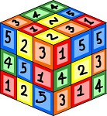

**SCIENCE**

The science courses offered help students to understand and debate important world issues, including the human impact on the environment and the social, economic, environmental and technological implications of science in society. A variety of experiments and practical investigations within all courses support the development of knowledge, understanding and the application of science skills which are then assessed in the final examinations at the end of Year 11. The courses available offer a valuable experience to all students regardless of their ability and aspiration and the school and science department will encourage students to follow the course to maximise their individual progress and achievement. All students entering Year 10 will be studying towards achieving the equivalent of at least 2 GCSEs at the end of Year 11. A brief summary of each course offered is given below:



**SEPARATE SCIENCES**

This is a very challenging and demanding course, particularly since the Government’s review of assessment methods, and while we encourage as many students as possible to study the separate sciences, their suitability for the course will be determined based on their work in Year 9 and only those students who are able to demonstrate good progress and achievement will be able to follow this option through to Year 11. This course suits students who wish to study Biology, Chemistry or Physics at A level and beyond, possibly with a view to studying science or engineering courses at University and pursue a career in a STEM related industry thereafter. This course will result in GCSEs in the three separate subjects Biology, Chemistry and Physics, and is only appropriate for those in the top sets for science. Students will need to use one of their option choices to be able to follow this course as it requires additional teaching time to the double award course.

**DOUBLE AWARD**

This qualification has been developed to inspire and challenge students of all abilities and aspirations. It covers all the main aspects of Biology, Chemistry and Physics and, following exams in May/June of Year 11, leads to the award of the equivalent of two GCSEs. All students, except those taking Triple Science, have to follow this course. Students who perform well in this course will be able to continue their study of the sciences at A level if they wish.

**MODERN FOREIGN LANGUAGES**

**Why study languages? How would a language help you in the future?**

A GCSE in a modern foreign language helps demonstrate a strong skillset to future employers, whatever career path you may wish to pursue. Studying a language will improve your:

Social skills Ability to work in a team

Communication skills Problem-solving skills

Confidence Cultural awareness

Open-mindedness Flexibility

**Our students say this about studying languages:**



“Languages enable you to travel to other parts of the world and feel like you’re part of the culture.”

“It’s fun, it’s creative and it’s enjoyable.”

“Knowing a language makes you more employable.”

“It gives you more options.”

**Languages at Longbenton**

The languages offered to GCSE at Longbenton are French or Spanish. You will follow a GCSE course with the AQA exam board. The GCSE course will build on the work you have already done in KS3.

You will study three themes across Years 10 and 11. These are:-

* Identity and Culture
* Local, National, International and Global Areas of Interest
* Current and Future Study and Employment

Each of the four language skills (Listening, Reading, Writing and Speaking) are equally weighted in terms of assessment. There are four separate exams at the end of Year 11.

Students will also gain an invaluable insight into customs, cultures and traditions of the country/countries where the target language is spoken, broadening their horizons and enriching their concept of the world around us.

**If you did not do Spanish in Year 9 you will not be able to opt for this subject at GCSE level.**

**GEOGRAPHY**

Studying Geography is highly regarded amongst employers and higher education providers. Whilst progressing through the GCSE course students will have the opportunity to express their opinions during group work and class discussion, as well as develop cross curricular skills using data collected from local fieldwork studies.

**Assessment**

There are 3 exams for the final assessment.

1. Physical unit worth 35% - 1 hour 30 minutes
2. Human unit worth 35% - 1 hour 30 minutes
3. Skills based exam which tests your knowledge and understanding of data you have collected on your field visits worth 30% - 1hour 15 minutes



**Subject content**

**1) Living with the Physical Environment.**

**a) The challenge of natural hazards** *covering tectonic hazards, tropical storms, extreme weather in the UK and climate change*

**b) Physical landscapes in the UK** *covering coastal and river landscapes of the UK*

**c) The living world** *covering ecosystems, tropical rainforests and hot deserts*

**2) Challenges in the Human Environment**

**a) Urban issues and challenges** *covering mega cities, cities in LICs, urban planning and regeneration, sustainable cities*

**b) The changing economic world** *covering factors influencing development, consequences of uneven development, reducing the development gap and economic futures of the UK*

**c) The challenge of resource management** *covering the supply and consumption of resources and how this can be managed more sustainably.*

**3. Skills paper**

**Two field visits to local areas-**

a) A field visit to a local coastline to collect data on physical processes

b) A field visit to Newcastle to research the land use in the city centre.

**It’s your world; why not learn more about it?**

**Choose Geography – get out and about!**

**Choose Geography – YOUR opinion matters**

**Choose Geography – it’s YOUR life and YOUR future**

**For more information see Mr Foley or Mr Moat**

**HISTORY**

We believe that there are five good reasons for studying History at GCSE.

(1) It gives you an understanding of the modern day world and so helps you to live in it and make sense of it.

(2) It helps you to understand the beliefs and attitudes of people outside Britain, and therefore broadens your mind and horizons.

(3) It develops your organisational and communication skills, which are essential in everything you do now, and will do in the future.

(4) It is interesting and fun to study, and you should pick subjects for that reason as well as for how “useful” they are.

(5) As an academic subject it is well thought of and shows good literacy and research skills.

The course from 2016 is a new GCSE. The new GCSE requires students to cover History from several different time periods. We follow EDEXCEL‘s syllabus and will cover:-

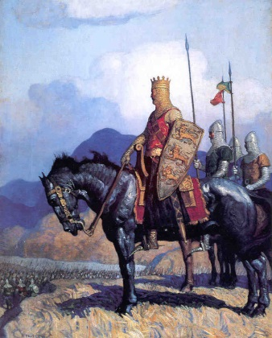

**1. Weimar and Nazi Germany, 1918-39**.

This unit links well to the content already studied in Year 9. This will look at Germany after World War One, the Rise of Hitler and the Nazis and life in Germany during the 1930s.

**2. The American West, C1835-c.1895**

This includes the study of the Native American Indians, the Wild West and the destruction of the Indian way of life.

**3. The reigns of King Richard 1 and King John 1189-1216**

This unit looks at two well known monarchs and their impact on England. Richard is famous as a legendary hero, ‘Richard the Lionheart’, who went on crusades. King John is seen as an ‘evil’ king who was unpopular and this unpopularity led to the ‘Magna Carta’ in 1215. You will study their reigns and consider whether the interpretations are justified.

**4. Crime and Punishment in Britain, C.1000-present day**

****This unit looks at the types of crimes and punishments in Britain over time. It examines how attitudes towards them have changed and helps to explain the issues facing Britain today such as policing, prisons etc. It includes a depth study on Whitechapel in late Victorian London. Students have already studied Jack the Ripper in Year 9 and this provides a link to the area and crime at the time.

**RELIGIOUS STUDIES (GCSE COURSE)**

Religion is one of the biggest causes of controversy in our world today and an understanding of it is essential for us to be able to understand the society in which we live. GCSE Religious Studies is a relevant, exciting and challenging course. It offers a huge opportunity to develop transferable skills such as critical thinking, debating and essay writing whilst addressing deeply important issues in an enjoyable setting.

If you choose to study GCSE RS, you will critically examine topics such as:

* **Christian and Buddhist beliefs and practices e.g.**
  + Beliefs about life after death
  + Beliefs about right and wrong – going to heaven or hell, producing good or bad karma
  + The significance of rites, rituals and other practices
* **Life and death issues e.g.**
  + Abortion and euthanasia
  + Animal and human rights
* **Relationships and families e.g.**
  + Gender and sexuality
  + Contraception and family planning
* **Crime and punishment e.g.**
  + Causes of, and solutions to, crime, including the death penalty
  + Forgiveness and rehabilitation
* **War and peace e.g.**
  + Nuclear war and weapons of mass destruction
  + Terrorism and violent protest

**RELIGIOUS STUDIES IS MOST DEFINITELY NOT ABOUT MAKING**

**YOU ‘RELIGIOUS’.**

**IT IS ABOUT ENABLING YOU TO THINK CRITICALLY, FOR YOURSELF,**

**ABOUT RELIGIOUS AND MORAL THEMES.**

Employers (especially the police, armed forces and caring professions) and universities regard GCSE Religious Studies highly. It helps to develop critical thinking and awareness of many important social issues.

**ART AND DESIGN**

The Art Department offers a two-year course leading to the AQA GCSE examination in Art and Design. Students will have the opportunity to study and practise a wide range of art and design activities and later may choose to develop their skills and interests in one particular area.

**Why choose Art and Design?**

In an increasingly technological age, when visual images play such an important part, the ability to communicate information visually is essential in both education and the world of work. There has been an information ‘explosion’ through advances in computers, television, video, film, and the media in general. Artists and designers make important contributions to all aspects of this work.

Art and Design would be a useful subject to choose wherever your main interests lie. You will develop skills which will help with your GCSE assignments in many subjects.

You will express your ideas creatively and learn how to present visual information (illustrations, graphics, diagrams) with greater confidence. Art and Design is an enjoyable subject which gives you the opportunity to develop the skills and knowledge to bring your own ideas to life.

There are many careers for which training and qualifications in Art and Design are either essential or desirable. Here are some examples:

Painter, sculptor, printmaker, photographer, graphic designer, advertising designer, illustrator, product designer, ceramic worker, stained glass designer, jeweller, theatre designer, fashion designer, film/video worker, animation designer, interior designer, textile designer, architect, exhibition designer, calligrapher, model maker, landscape gardener, teacher, nursery nurse, window dresser, art historian, painter and decorator, hairdresser, beautician, travel courier, archaeologist - and many more.

**Course Outline**

You will be encouraged to develop your personal imaginative ideas and your practical and design skills. You will be expected to use a sketchbook regularly to improve your visual awareness by recording various aspects of the natural and human environment.

Candidates should produce practical and critical/contextual work in one or more areas:

1. Drawing and Painting

2. Mixed Media

3. Sculpture

4. Print making

5. Lens-based or light-based media: film, animation, video and photography

Throughout the course reference will be made to the work of artists and designers past and present. Critical appraisal of their work, using the appropriate vocabulary, will be an important part of the course, together with the development work you will produce in your sketchbooks.

You will be expected to take an active interest in the various aspects of the visual arts. Visits to galleries and local colleges to see exhibitions of art and design work will form part of the course.

Homework assignments will be set and contribute to the final coursework grade.

Students will be expected to purchase their own sketchbooks and pencils, and bring them to every art lesson. The department offers quality materials at cost price.

**GCSE Photography**

The Art Department offers a two-year course leading to the AQA GCSE examination in Art and Design (Photography).

In this course, you will complete a series of coursework projects (Which amounts to 60% of the overall grade) and an Externally Set Assignment (Examination). (Which will contribute to 40% of the overall grade).

You will learn to develop ideas and experiment with different photographic techniques, and digital manipulation. You will learn to use Photoshop and Lightroom to manipulate your images.

**Course Outline**

You will be encouraged to develop your skills in creating digital visual images. You will be expected to use a sketchbook regularly, to improve your visual awareness by recording various aspects of the natural and human environment in preparation for you photoshoots, recognising awareness of composition and creative insight.

Candidates should produce practical and written critical/contextual work, studying the work of other Photographers, Visual Artists and Designers.

You will be expected to take an active interest in the course. Visits to sites of interest and regular photoshoots will be expected as part of the homework task schedule.

Homework assignments will be set and contribute to the final coursework grade.

Students will be expected to purchase their own sketchbooks and pencils, and bring them to every Photography lesson. The department offers quality materials at cost price.



**CACHE – Child Care**

Students will learn about children (from birth to 5 years) at different stages in their growth and development. They will also learn how to care for children and how to work with parents, carers and other professionals in a childcare setting.

Assessment of students will be completed by two assignments for each unit of work and an externally set and assessed multiple choice question paper.

Upon successful completion of the course the CACHE qualification can open the door to a wide range of careers in child care, ranging from playwork and child minding to teaching and nursing.

This course is equivalent to one GCSE grade A*- D.

If you would like to know more about either of these courses, please do not hesitate to ask your FTC teachers.



**DESIGN TECHNOLOGY**

AQA GCSE Design and Technology will prepare students to participate confidently and successfully in an increasingly technological world. Students will gain awareness and learn from wider influences on Design and Technology including historical, social, cultural, environmental and economic factors. Students will get the opportunity to work creatively when designing and making and apply technical and practical expertise.

This GCSE allows students to study core technical, designing and making principles, including a broad range of design processes, materials techniques and equipment. They will also have the opportunity to study specialist technical principles in greater depth.

**Where will this qualification take me?**

These qualifications are useful in progressing to A level Product Design. This course can lead on to careers, apprenticeships or University studies in the construction, manufacturing, design and engineering sectors.

**What is assessed?**

This qualification is linear which means that students will sit all their exams and submit all their non-exam assessment at the end of the course.

**Paper 1** is an external 2 hour examination worth 100 marks and makes up 50% of the GCSE qualification. It consists of the following units:

* Core technical principles - A mixture of multiple choice and short answer questions assessing a breadth of technical knowledge and understanding.
* Specialist technical principles - Several short answer questions and one extended response to assess a more in depth knowledge of technical principles.
* Designing and making principles **-** A mixture of short answer and extended response questions.

The **Non-Exam Assessment (NEA)** is a design and make task and again makes up 50% of the GCSE qualification, lasting approximately 30–35 hours. It focuses on the same three principles found in Paper 1 above.

Assessment criteria:   
• Identifying and investigating design possibilities  
• Producing a design brief and specification  
• Generating design ideas  
• Developing design ideas  
• Realising design ideas  
• Analysing & evaluating

**FOOD**

**General Information**

The Food course will equip students with the knowledge, understanding, skills and creativity they need to cook. It will give them the ability to apply the principles of food science, nutrition and healthy eating. Students will be able to make informed decisions about a wide range of further learning opportunities and career pathways and will develop vital life skills so they can feed themselves and others affordably and nutritiously. The students will learn a wide variety of practical cooking techniques to prepare and cook food healthily, whilst gaining a proper understanding of the scientific principles behind food and nutrition. The course allows students to show their creative flair by the modification of recipes to improve their nutritional and sensory profile. Students will develop their understanding of Food and Catering industries. It promotes independent thinking, decision making, planning and organisational skills. Above all, it allows students to create a wide selection of delicious food products.



**Subject Content**

A great deal of the course will be taught through practical sessions to ensure a greater understanding of the working characteristics of different food materials. The students will develop knowledge and understanding of the functional properties and chemical processes as well as the nutritional content of food. There will be a wide range of cookery skills learnt, and a clear understanding of food safety and hygiene. Students will be given the opportunity to apply this knowledge both in their cooking and theory sessions.

**DRAMA**

Are you imaginative? Do you want to develop your creativity?

Do you enjoy:

* expressing yourself in an active and exciting way
* working in a group
* contributing your ideas and taking on board those of others
* exploring ideas by putting yourself in other people’s shoes
* playing many parts in different imaginary situations
* creating your own drama work
* looking at plays written by other people
* learning about creating a character and playing this character in performance
* watching live performances

**Then this course is for you!**

Over the two year course you will work in groups to explore new techniques, ideas, issues and stories; explore scripts and how they might be staged; devise pieces of drama inspired by many different stimuli materials, including images, music and objects; keep a record of your understanding and ideas in a written drama log and visit the theatre to explore how productions create meaning.

The syllabus is divided into 3 components:

**Component 1: Understanding Drama 40%**

There are two areas of study for this component. You will participate in practical workshops exploring a set play text (Blood Brothers) and evaluate and analyse a live theatre production you have seen. Your knowledge and understanding will be assessed through a 1hr 45min written exam.

**Component 2: Devising Drama 40%**

There are two assessment tasks to be completed for this component. You will work in small groups to create and develop ideas from different stimulus materials, such as images, poems or music. You will be expected to research your topic, develop your own ideas, collaborate with others, rehearse and refine your work and evaluate the process of creating your devised drama. This task will be assessed through a written devising log. You will also be assessed on the final performance of your piece of meaningful drama. This will be filmed and sent to a moderator.

**Component 3: Text in practice 20%**

There are two assessment tasks to be completed for this component. You will work in small groups to rehearse and perform two key extracts from a play of your choice. You will explore the entire text in your group and choose extracts which are pivotal to the plot, characters or themes of the play. You will be assessed by a visiting examiner.

**Further Information**

When an employer sees GCSE Dramaon an application form, they see a person who is confident, with excellent communication and problem solving skills, with the ability to work as part of a team. Drama will help you with interviews for Universities and jobs. In any work place you will need to work with others, and speak confidently. Drama helps you to develop these skills.

**MUSIC**

Music is an engaging and challenging GCSE course for students wishing to develop their performance, composition and listening skills. There is an equal balance of theoretical and practical based elements within the course. You must be willing and able to perform on your instrument as well as be open minded to listening to and learning about a wide range of musical styles and genres. The ability to read and notate music is highly beneficial; it is essential that you are prepared to develop your skills in this.

**Edexcel GCSE Music consists of three units:**

**Unit 1 – Performing (30%)**

You will prepare a performance programme totalling at least 4 minutes. This programme will consist of at least 1 solo piece and at least 1 ensemble piece which feature you on any instrument (including voice). The guideline standard for repertoire is grade 4; we will advise you on choosing pieces of a suitable standard. The performance recordings will be made during Year 11; performances will be internally assessed and externally moderated. It is hugely valuable if students are able to have instrumental or vocal lessons in order to gain additional specialist support for this area of the course. Belonging to a musical ensemble such as Senior Choir, Orchestra or Guitar Legends is also strongly advisable. Performance coursework will be internally assessed and externally moderated.

**Unit 2 – Composing (30%)**

You will prepare two compositions totalling 3 minutes. This will consist of one composition in response to an exam board set brief as well as one free composition. In the majority of cases, students notate their compositions on the Sibelius notation software you will have access to within the department. Composition coursework will be internally assessed and externally moderated.

**Unit 3 – Appraising (40%)**

You will study four main areas of music for this unit:

1. Instrumental Music 1700-1820

2. Vocal Music

3. Music for Stage and Screen

4. Fusions

Within each area of music there will be two set works which we will analyse in detail in terms of the musical elements (including harmony, melody, and rhythm). These set pieces are varied and accessible, ranging from *Defying Gravity* (from the Stephen Schwartz musical ‘Wicked’) to *Killer Queen* (from the Queen album ‘Sheer Heart Attack’). In addition to this, you will be tested on music that is related to these areas of music but has not been studied in class; to prepare for this we will listen regularly to a wide range of musical styles linked to the set works.

You will sit a listening exam lasting 1 hour 45 minutes at the end of year 11 in which you

will be tested on these eight set pieces as well as some unheard listening.

**BUSINESS STUDIES**

Most of us will end up working in some form of organisation, such as a manufacturing firm, an office or retailer. Alternatively, there may be an opportunity for you to open up and run your own business.

Business Studies is an exciting subject that relates to the world of work and gives students the opportunity to develop skills that can be applied to all working roles. Group activities, presentations, the study of job application, recruitment and selection as well as creating a business plan give students essential business skills. The course also helps you to develop an understanding of personal finance and the external factors affecting a business such as stakeholders, the economy and the government.

You will examine and explore questions such as:

* How is a business formed?
* How do they market and sell their products?
* What determines whether a business makes a profit or a loss?
* How does a business raise finance?
* How does a business compete and stay ahead of competition?
* How does a business recruit, train and develop its workers?

Business Studies will give you the key skills needed to be an attractive employee. It will help you to develop your team working, leadership and communication skills.

**Progression**

This qualification has been designed to aid progression to further study at A level. Alternatively, candidates are able to enter employment or embark on an apprenticeship.

For further information on any aspect of the content please see Ms Teale in EV14.



**Creative iMedia**

This will engage students with the latest technologies and software applications. The qualification will enable students to become independent and adaptable users of ICT, to acquire and apply creative and technical skills and to develop their understanding of a wide range of technologies. They will gain an understanding of how ICT is used in the media sector and undertake projects to try this themselves.

This course provides learners with essential knowledge, transferable skills and tools to improve their learning in other subjects with the aims of enhancing their employability when they leave education. It will encourage independence, creativity and will equip learners with a range of creative ICT skills and provide opportunities to develop, in context, desirable, transferable skills such as research, planning, and review, working with others and communicating creative concepts effectively.

**Topics**

This course will enable the students to develop a variety of skills with a range of topics to be chosen from including:

* C:\Program Files\Microsoft Office\MEDIA\CAGCAT10\j0292982.wmfGraphics
* Multimedia
* Video
* Web Design
* Animation
* Game Design

**Assessment**

Assessment will mostly be through coursework; however, there is one written paper which will contribute to 25% of the student’s final grade.

**Progression**

This qualification has been designed to aid progression to further study, including GCEs, BTECs and Diplomas in IT, Computing and related subjects.

Alternatively, candidates are able to enter employment or embark on an apprenticeship.

**Who Would This Suit?**

This is a creative course which requires students to be able to effectively design media to meet a given purpose and audience. Students should be able to consider the aesthetics of their work as well as the practical aspects. It would best suit students with a creative side who are looking for a course which will help them to develop this.

**For further information on any aspect of the course please see Mrs Wouldhave**

**GCSE COMPUTER SCIENCE**

Computing is of enormous importance to the economy, and the role of Computer Science, as a discipline itself and as an ‘underpinning’ subject across industry, is growing quickly.

Computer technology continues to advance rapidly and the way that technology is consumed has also been changing at a fast pace over recent years. As individuals, we are invariably all users of this ever-changing technology. This course challenges students to be creators rather than consumers. There will be two areas of study.

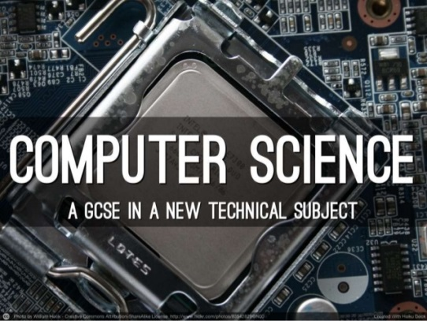

**Technology**

The course will give students a real, in-depth understanding of how computer technology works. Students will no doubt be familiar with the use of computers and other related technology from their other subjects and elsewhere. However, this course will give them an insight into what goes on ‘behind the scenes’, which many students find absorbing.

**Programming**

The course will develop critical thinking, analysis and problem-solving skills through the study of computer programming. For many students, it will be a fun and interesting way to develop these skills, which can be transferred to other subjects and even applied in day-to-day life. In this respect, this course will make an excellent preparation for students who want to study or work in areas that rely on these skills, especially where they are applied to technical problems. These areas include engineering, financial and resource management, science and medicine.

**Who Would This Suit?**

This is a course that offers high levels of challenge for any student who chooses to study it. It would be best suited to students who are already studying at high levels in Maths, English and Science. Students opting for this course will have to deal with difficult and abstract concepts. It requires clear logical thought and the ability to use algebraic concepts confidently.

**For further information on any aspect of the course**

**please see Mrs Wouldhave in EV12.**

**GCSE PE AND BTEC SPORT (exam choice)**

The Physical Education Department offers two, two-year examination courses in Physical Education, one leading to a GCSE qualification, the other to a Level 2 BTEC First Award. A decision will be taken by the PE Department as to whether the GCSE or BTEC course offers the best chance of success for each student wishing to study Physical Education.

The GCSE PE qualification is an excellent course for any student wishing to further their understanding of the human body, and develop their practical performance in a range of activities. Students will work towards two exams, one looking at human anatomy, the other at sports psychology, sociology and health and well-being; both exams will count for 30% of the final grade. GCSE PE pupils must show strong practical ability, as they will need at least three different sporting activities that they can show competence in; these three activities count for another 30% of the final grade. The final 10% of the course is assessed through an evaluation of performance, whereby pupils have to demonstrate their understanding of one of their physical activities, by assessing their own or another student’s performance. For students wanting to take the GCSE PE option, it is vital they are performing outside of school in at least one activity.

The BTEC First qualification in Sport has been designed to be an engaging and stimulating introduction to the world of physical education; offering a vocational route through Key Stage 4. The First Award in Sport comprises core and specialist units. The two compulsory core units are Fitness for Sport and Exercise (Unit 1) and Practical Sports Performance (Unit 2). Unit 1 is assessed externally through an examination, whereas Unit 2, and the optional units, are assessed internally through coursework based tasks, such as verbal presentations, work based assessment and practical performance. The optional units are: The Sports Performer in Action and Leading Sports Activities.

Both GCSE and BTEC courses are ideal for students who have a strong interest in sport and physical education, and would like to study them further. The courses are a valuable preparation to many post-16 sports orientated courses such as A Level PE and BTEC Sport, both of which lead to a plethora of potential university courses or job prospects.



**RELIGIOUS AND SOCIAL DEVELOPMENT**

**(non exam)**

Our school, like all schools, is legally obliged to teach some Religious Studies through the Locally Agreed Syllabus (in this case, North Tyneside) and some Personal and Social Development. Religious and Social Development is very similar to the ‘PSD’ lessons which students receive in KS3 but occasional lessons take into account religious views to keep in line with the Locally Agreed Syllabus.



**Question** **What is RSD?**

**Answer** It is a specially designed course that combines Religious Studies and PSD for all students in Years 10 and 11. It prepares students for the challenges, opportunities and responsibilities of adult life.

**Question** **How does it do that?**

**Answer** The skills students have developed in PSD are combined with some insights into the ethical viewpoints of different religious and other worldviews.

**Question** **What topics will we cover?**

**Answer**  Morality – right and wrong, abortion, euthanasia, the death penalty, religious teachings, suffering and poverty, the world of work, work experience, human rights, relationships, marriage and parenthood (including sex and relationships education).

**Question** **Is there an examination?**

**Answer** No, but there are two attainment targets that we informally assess: learning about religion and learning from religion. This means students will learn to investigate, apply, recognise, explain, evaluate and interpret as well as reflecting on their own and others’ views. Students are given regular written and verbal feedback to push them to develop their critical thinking skills. All these things will form an important part of students deciding upon their beliefs and behaviour.

**PHYSICAL EDUCATION (non exam)**

Physical Education is a compulsory subject throughout the School. The course provides a well-balanced programme of activity and is based upon practical performance in team games and individual sports.

During the year the following games and activities are covered:

Badminton

Netball

Fitness

Volleyball

Trampolining

Rugby

Hockey

Basketball

Handball

Dance

Table tennis

Athletics

Rounders

Softball

Cricket

Tennis

Health and fitness is an integral part of the course and plays an important part in every lesson.

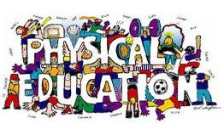

**Travel and Tourism**

The core units will involve a number of the following areas of learning:

The UK Travel and Tourism Sector – this covers the main types of

tourism in the UK, the contribution that travel and tourism makes to the UK

economy and the different component industries that make up the UK travel

and tourism sector.

UK Travel and Tourism Destinations – this covers what the different

types of UK destinations have to offer, as well as locating tourist UK destinations

and routes.

The Development of Travel and Tourism in the UK – which looks at

developments that have shaped the sector and how the UK travel and tourism

industry has developed as lifestyles, interests and technology have changed,

giving an insight into why it is such a dynamic sector.

International Travel and Tourism Destinations – which looks at

international travel and tourism destinations and gateways and reasons for

their appeal to different visitors.

Factors Affecting Worldwide Travel and Tourism – covers the influential

factors on tourism and why events such as natural disasters can have a significant

impact on the sector.

The Travel and Tourism Customer Experience – which looks at the needs

and expectations of different types of customer in the travel and tourism sector

and how organisations address these.

Assessment will be through production of portfolio and coursework as well as a final exam.



**NOTES**

**TERM DATES**

Spring Term 7 January – 5 April 2019

Half Term Monday 8 February – Friday 22 February 2019

Easter Friday 8 April – Friday 22 April 2019

Summer Term 23 April – 19 July 2019

Bank Holiday Monday 6 May 2019

Half Term Monday 27 May – Friday 31 May 2019

