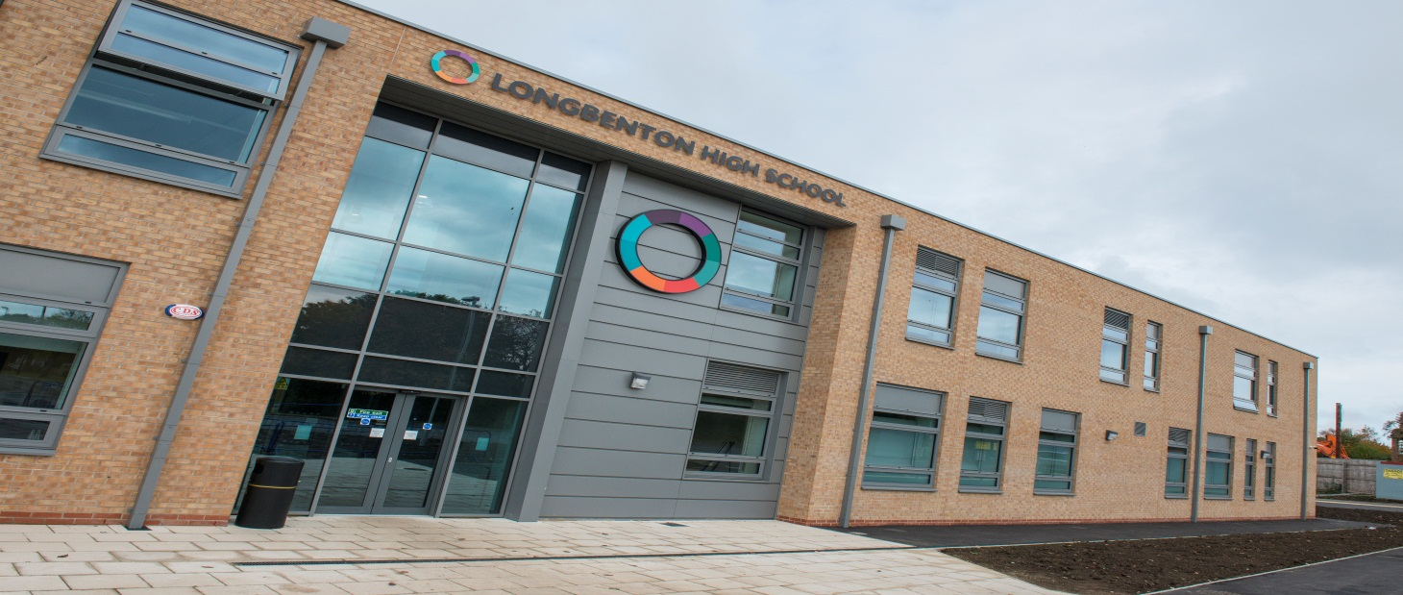

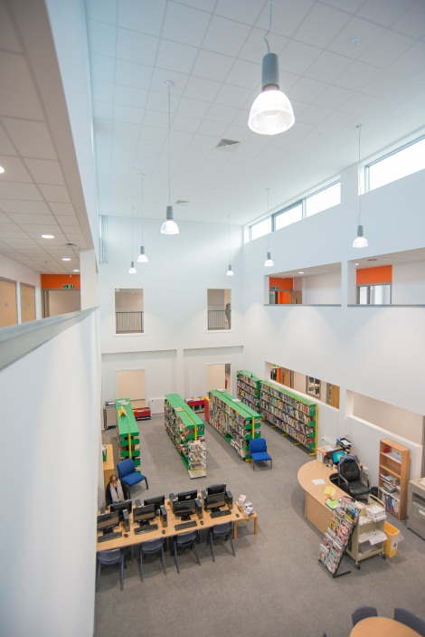
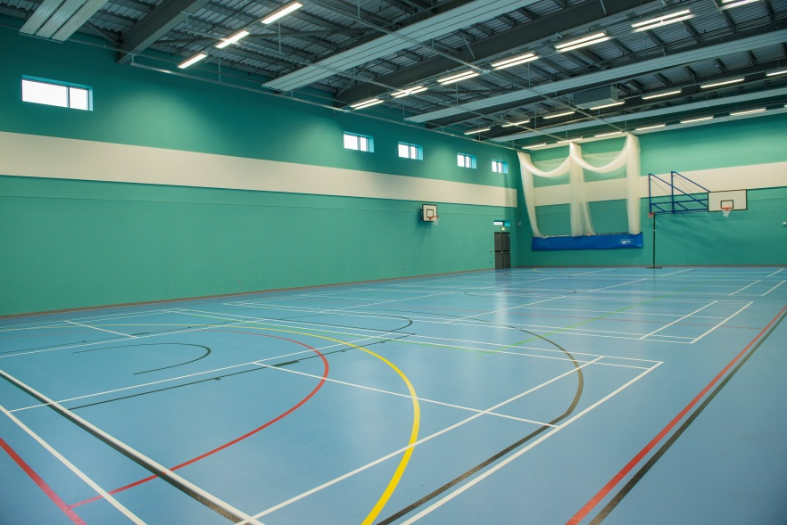
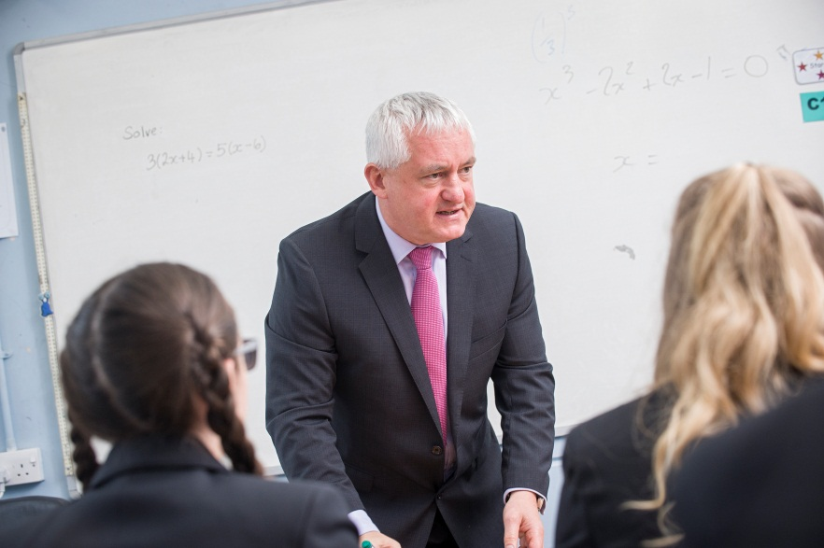

Applicant pack,
Teacher of Humanities (Geography)
Welcome from the Headteacher

Dear Applicant

Thank you for considering the full time permanent post of Teacher of Humanities. At Longbenton we have a corridor of our new build devoted to a group of subjects that we call Explore. These subjects are very popular at Longbenton both as academic subjects and ones that students enjoy. We are looking for someone who can teach Geography to GCSE standard but who can also contribute to other courses in Explore including History. The post is well suited to both NQTs and those with more experience. Our new school is a fantastic place to work and the facilities in Explore are particularly impressive.

These are very exciting times for us and this is a wonderful opportunity for someone to join us at a key point in our development and be part of something innovative, challenging and rewarding. I joined the school myself in September 1998 having worked in two other North Tyneside schools prior to that. I was appointed as Acting Headteacher in January 2015, following the retirement of a long-serving Principal, and that position was made permanent in September 2015. I have stayed at Longbenton so long because the school epitomises my personal ethos towards education: it is inclusive, comprehensive in its intake and a focal point of the local community. I have always been impressed by the quality and commitment of the staff and students at Longbenton and I know that together we can create a bright future for the school.

Making the decision whether to apply for a new post is always challenging on a number of levels. With this in mind I have hope that I have provided you with all of the information that supports you in choosing whether to proceed and make an application. You will be able to see more of us as a school through our website, www.longbenton.org.uk, but if there is additional information that you need in making your application please feel free to get in touch.

OFSTED came to inspect us in May 2015 and rated us as a “good” school, which agreed with our self-evaluation. A copy of the report is available on our website. The timing of the inspection was a positive for us as it allows us to focus on the challenges and opportunities that the move to our new school has given us. We are ambitious both for our young people and for us as a school and want to be the best that we can be in all that we do. I am looking for someone who will earn the respect of a very committed department through their professionalism, hard work, talent and enthusiasm. We are a very cohesive staff who are working together collaboratively to deliver the best education that we can for the young people in the community that we serve. As you would expect, challenge and accountability are integral to what we do but fostering good relationships and treating people decently is important to us too.

Should you choose to apply for this post please pay particular attention to the Person Specification and the Job Description, demonstrating how you meet the requirements, as this will be used in deciding which candidates to shortlist. Electronic applications are preferred and please limit your letter of application to two sides of A4.

I hope that this is the right opportunity for you and good luck with your application.

The closing date is 12 noon on Thursday 30 March 2017 with interviews soon after.

Paul Quinn
Headteacher

INFORMATION ABOUT THE SCHOOL
Longbenton High School is a highly successful community technology college within the Metropolitan Borough of North Tyneside. It is situated adjacent to the City of Newcastle upon Tyne which is the major cultural and sporting centre of the North. It is also close to the borders with Northumberland, with opportunities there to enjoy its unbroken countryside, unspoilt (although cold) beaches and places of historical interest.

The roll of the School is around 900 of whom about 120 are Post 16 students. The catchment area comprises two large municipal post-war housing developments in addition to substantial areas of private housing. Our intake is broadly in-line with national averages in terms of prior attainment, FSM uptake and levels of deprivation. Our students have a positive approach to their learning and OFSTED (May 2015) commented “The behaviour of students is good. Their conduct around the school is good. Students are polite and friendly to each other, and courteous towards visitors.”
Our curriculum has become increasingly personalised. Students in Key Stage 3 follow a core curriculum, although there are options available to students according to their ability and interests. For example, students in Year 9 have option choices around which foundation subjects they follow. Many students start examination work during Year 9 in a variety of courses.

In Key Stage 4, there is again a core curriculum for all students, but students follow different pathways through the curriculum. We look to tailor the curriculum according to the needs of the students. From Year 7 starting points that are typically average, the vast majority of our students make good progress to attain typically above average standards, by the end of Year 11.

The school works closely with 2 other local high schools to provide a wide range of ‘A’ level and other post-16 courses. Students may take all of their courses at Longbenton, or, alternatively, are taken by minibus to study a particular course in one of our partner schools.

We pride ourselves in the quality of our teaching. In our inspection report of May 2015, OFSTED commented on the quality of teaching, saying, “Teaching is mainly good, with some outstanding practice. There is good teaching in school in all subjects.” Students have an earlier finish each Tuesday to allow a weekly two hour CPD programme for teachers. Through our CPD programme, we endeavour to raise further the skills of our teaching staff and this is an on-going whole school priority.
We are a strategic partner in the George Stephenson Teaching School Alliance which allows us to work collaboratively on CPD with other schools and also Newcastle University.

We have a highly developed pastoral system with teaching Year Leaders looking after the overall welfare of students, supported by very committed Form Tutors. The law relating to collective worship is observed and tutors are expected to take tutor assemblies using the assembly theme for the week.

In September 2009, we opened the Melrose Centre for students who have ASD. This is staffed by specialist teachers and learning support assistants. Some of our Melrose Centre students are able to access parts of the mainstream curriculum.

Along with a number of other schools in North Tyneside, the School acquired Trust Status in September 2010. The schools that have acquired trust status have come together to form the North Tyneside Learning Trust in partnership with the Local Authority, higher education institutions, the local FE school and a number of businesses. This will enable our students and staff to benefit from very strong partnerships across North Tyneside.

We pride ourselves in being a very caring community which is able to foster good relationships among its members. Longbenton High School is an exciting place in which to work, with many new developments taking place.

Our new school opened in September 2016 with state of the art facilities. It has been a step change in education for us and our local community. Our old school served us for more than 60 years across a number of different buildings across the site but we are now in one building all under the same roof. It has greatly lifted our sense of community and togetherness. Longbenton High School is a fantastic place to work.



EXAMS / CURRICULUM

KEY STAGE 3 CURRICULUM

All students in Year 7 will study the same subjects, mostly in ability sets. Whatever the nature of the grouping which is in operation, students will be taught at the most appropriate level according to their ability. We are, for example, committed to providing challenging activities for our most able students. Special Needs support is provided where necessary. The curriculum is broad and balanced and reflects the requirements of the National Curriculum.

At the end of Year 8 all students are given an element of choice in their curriculum in Year 9. This means that pupils spend longer on subjects that they enjoy and are doing best in as well as being better prepared for starting GCSE in that area of study should an individual choose to continue in Year 10 and 11.

By Easter of Year 9 all pupils will have completed their Key Stage 3 studies and begun GCSE courses in Maths and Science.

KEY STAGE 4 CURRICULUM

In March of Year 9, students choose their options for Key Stage 4, in most cases leading to GCSE. Pupils are given guidance about courses through a booklet, careers advice and an interview with senior staff. There is a Parents’ Evening for consultation with staff. Every effort is made to ensure that pupils have a balanced curriculum suited to their individual needs. Changes have been made to the choices students are offered to reflect Progress 8 but we do not currently make the EBacc compulsory for anyone.

For some students, for whom it is appropriate, we personalise the curriculum still further to include working with high quality vocational placement providers to broaden their educational experiences beyond the academic. This is complimented by the study of ASDAN courses in Employability Skills as well as the Certificate of Personal Effectiveness course at Level 2.

POST 16 CURRICULUM

We offer a wide range of AS and A2 Levels and Advanced Vocational courses to challenge the large numbers of students wishing to continue in full time education with us after their GCSEs.

Local schools and colleges are increasingly working with each other. We have formed very close links with George Stephenson High School and Seaton Burn Community College with whom we collaborate on post 16 provision.

The great majority of our Sixth Formers’ lessons are delivered here but we also transport students between the schools for jointly delivered courses and have done this very successfully for a number of years now.

PASTORAL STRUCTURE

At Longbenton we have a teaching Year Leader who has key responsibility for the pastoral welfare of their year group. They are led by one of the Assistant Headteachers who has overall responsibility for all issues pastoral including behaviour and attendance.

ENRICHMENT

Our curriculum is supplemented by a wide range of clubs, activities, trips and visits from a wide range of areas including music, drama and sport.

NEW BUILD ZONES

Within our new build, Longbenton High School, the majority of subject areas are housed in different zones:
- communicate – English and MFL
- e-valuate – maths and computing
- explore – history, geography, RE, politics, Philosophy & Ethics and RSD
- discover – science
- perform – music and drama
- support – SEN, behaviour support
- melrose – our ASD centre
- post 16 – our KS5 area
- create – art, DT, food, textiles, child studies, photography
- active - PE

EXAMS

In general terms we take students who are at about national averages in KS2 and get better than national average results by the end of KS4. We achieve this through good teaching and an effective pastoral system.

5+ A*-C inc En Ma | Percentage
2015 | 60%
2014 | 58%
2013 | 64%

The way that exam results are reported changed in 2016. Our headline figures were:

Basics measure A*-C in both English and Maths 61%.
Progress 8 measure -0.21
Attainment 8 measure 4.68

At post 16 the great majority of our students follow an academic pathway and in 2016,
APS per entry 28.3 with an overall average grade per entry of C-

THE SENIOR LEADERSHIP TEAM

Longbenton’s Leadership Team consists of:
  - Headteacher
  - Deputy Headteacher
  - 3 Assistant Headteachers and the Director of Support Services

The team meets at least twice each week to share updates on developments in all areas and to plan future strategy and events.

THE GOVERNING BODY

The school has a very supportive and hard-working Governing Body. It is quick to recognise the achievements and commitment of staff and offer thanks. It is equally vigilant of areas of concern or difficulty and closely monitors the management of the school through its Committee structure.
DEPARTMENTAL OVERVIEW - GEOGRAPHY DEPARTMENT

We are a very friendly, successful and forward looking department within our new school, with excellent relationships and collaboration with both the History and RSD departments.
The department consists of two full time teachers and two part-time teachers of Geography covering all key stages. The department believes itself to be progressive in its outlook and is continually experimenting with new teaching and learning styles to aid the progress of all students, and raise attainment to the highest possible levels. We also have a flexible approach towards learning, and consequently adopt a wide range of strategies to deliver the best possible outcomes for our students.
We believe that IT has an integral role to play in the delivery of the geography curriculum and are pro-active in the use of many of the new technologies available. This is aided by the fact that the department has excellent facilities with each room having access to 65 inch ‘Clevertouch’ screens which encompass a large selection of apps for use in the classroom. We also have the option to use class sets of ipads and good access to several of the new computer suites in the school.
The department has recently purchased new GCSE and A-Level text books, so excellent provision is made for the two new syllabi in a more traditional context. We also subscribe to a range of periodicals and on-line resources which also enhances the learning of the students.
At Key Stage 3 the following topics are covered;
- Map Skills
- Our amazing world
- Settlement
- Weather and Climate
- Country case study: Kenya
- Economic Activity and Globalisation
- Rivers and coasts
- Tectonic Hazards
- Population and Development
- Country case study: China

Pupils will also have opportunity to take part in field visits to develop skills of field work, a core element of the subject.
At key stage 4 the department follows the AQA GCSE specification 8035. The topics studied are as follows;
Physical elements
- The Challenge of natural Hazards :- Tectonics, Weather and Climate change
- The Living World and Ecosystems :- Tropical Rainforests and Hot Deserts
- The Physical Landscape in the U.K. :- Coasts and Rivers
Human elements
- Urban issues and Challenges
- The Changing Economic World
- Resource Management:- Water
Pupils will have the opportunity to take part in a range of field visits in key stage 4 to collect data for the new Geographical Applications paper.

HISTORY DEPARTMENT
The History Department of Longbenton High School consists of three well qualified specialist teachers who work together as an effective team. You would be well supported within this team. Each member of the department has their own classroom, each of which has a state of the art interactive Clevertouch screen. The department is well resourced with textbooks and interactive materials and we are dedicated to continually improving the range of teaching and learning methods used. We take a collaborative approach to the progression of the department through both weekly departmental meetings and CPD and INSET sessions.
The History Department continually reviews its Schemes of Work to incorporate the best practice from across the department. We have recently embedded a more skills based curriculum and we are taking a lead in the use of innovative teaching styles and Assessment for Learning. Our wide range of teaching and learning styles aims to raise achievement across the department as well as ensuring that students enjoy their study of the past.
The department is dedicated to enhancing the History curriculum for its students and annually hosts a number of events that aim to provide activities that ‘bring History to life. The History Department’s Programmes of Study includes the following:
- Year 7 start with a unit on What is History? and study Medieval England (1066-1500) and The Tudor period.
- Year 8 study The Civil War and Black Peoples of the Americas. Life in Industrial Britain.
- Year 9 follow a short unit of work on Britain 1750-1900 including the case of Jack the Ripper and The 20th Century World.
RELIGIOUS STUDIES AND PERSONAL SOCIAL DEVELOPMENT DEPARTMENT
The RS and PSD Department is a cheerful, energetic department, devoted to inspiring students’ curiosity about human behaviour and beliefs and helping students to boldly take charge of their own lives. Students enjoy RS and PSD because of the dynamic teaching in the department and the fact that they are encouraged, in various ways, to develop skills of reasoning, critical thinking and debating.
Key Stage 3 Religious Studies comprises an introductory course on beliefs and critical thinking, leading into study of the six main world religions. Later on in Key Stage 3, students study challenges to religious belief such as scientific development and the problem of evil. A recent addition to our Year 9 course (along with some references in our Y7 course) is the study of secular humanism – ‘living a good life without God’. Key Stage 3 Personal and Social Development begins with attitude and skill developing lessons which help students settle into Year 7 and make the most of life at LHS. The rest of Key Stage 3 and 4 PSD involves study of social issues such as bullying, e-safety, relationships and being a good citizen. We constantly adapt lessons and schemes of work in both RS and PSD to reflect developments in school and world affairs; we value input from students, all members of the department and other school staff in the development of our schemes of work. We believe that our own curiosity, adaptability and pragmatism are some of the things which make us a strong department. Homework clubs and debate club run by the department enhance students’ knowledge and enjoyment of our subjects.
You would be made most welcome in our department of three teachers – we feel very strongly about being inclusive and supportive toward staff as well as students. A wealth of resources, including all the materials needed for every lesson, would be made available to you along with advice and help from us whenever you need it.
JOB DESCRIPTION

TEACHER OF HUMANITIES – Main Scale

Reporting to: Curriculum Leader for Geography

- Ethos

- to contribute to the development of the school vison, values and ethos, priorities, targets and plans for improvement
- to have the highest aspirations for students and to be accountable for ensuring the best possible outcomes for students in your classes
- to model professional behaviour and attitudes around the school to ensure that the highest standards of appearance and conduct are met
- contribute to wider school life and the overall vision, values and guiding principles of the school, including through providing opportunities for our students to participate in extra-curricular activities.

- Role Purpose

- to plan for progression across the age and ability range
- to ensure high standards of teaching, assessment and feedback leading to good and outstanding progress and attainment for students in your classes
- to establish a clear framework for positive classroom management based upon appropriate implementation of department and whole school policies

- Teaching and Learning

- to teach challenging, well-organised lessons and sequences of lessons across the age and ability range
- to take responsibility for your own professional development and remain up to date with current practice, undertaking any relevant training

- Administration
- to attend appropriate school meetings
- to contribute to regular departmental meetings and CPD
- to ensure that the school’s administrative procedures are followed
- to ensure that reports to parents are completed to a good standard and are completed punctually
- to comply with policies and procedures relating to child protection, health, safety and security and confidentiality, reporting any concerns

- Student Welfare
- to promote the giving of effective guidance to students in matters relating to the curriculum (e.g. in relation to careers)
- to be accountable for ensuring a secure and positive climate to learning and behaviour of students in your classes, including through the implementation of the school’s Behaviour for Learning programme
- to be a form tutor involving:
- monitoring student progress and achievement
- providing first line support and guidance
- attending school assemblies and conducting tutor group assemblies on the theme of the week
- carrying out administrative tasks relating to the tutor group.

(8) To comply with any other reasonable request from the Headteacher
Person Specification
Teacher of Humanities

 | Essential | Desirable
Experience | To be or have the potential to be an excellent teacher, demonstrating enthusiasm and a commitment to education  Have successful experience of teaching geography across the age and ability range  Able to monitor and evaluate students’ progress and staff performance  Experience of teaching geography at KS3 and KS4  The potential to teach geography successfully at KS4. | The ability to teach KS3 History.  The potential to be able to teach KS3 PSD and KS4 RSD.
Qualifications | To have Qualified Teacher Status  To have a degree | Prepared to embark upon further training as required.
Practical and Intellectual skills | Be an effective team member  Able to initiate ideas, set own targets and meet own and other people’s deadlines  Have effective communication skills, both written and verbal, to address a variety of groups and individuals including parents  Have very good IT skills  Have the ability to work independently but to consult and liaise regularly  Be approachable and willing to help students both in and outside of lessons  Be interested in children as individuals, in how they learn and be committed to the comprehensive ideal  A strong academic background. | Have evidence of commitment to, and understanding, of collective responsibility
Disposition and Adjustment | Be passionate and dynamic about the subject.  Be resilient, committed, flexible and able to motivate students of all abilities.  Have energy and persistence, tempered with humour.  Able to work closely with a wide range of staff and students and establish and maintain good relationships through good interpersonal skills.  Have commitment to professional development.  Demonstrate personal and professional integrity, modelling values and vision.  Be prepared to participate in extracurricular activities. | An awareness of good practice in identifying individual needs and providing appropriate teaching.
Equal Opportunities | Must have an understanding of and commitment to the school’s equal opportunities policies and procedures.  To be able to demonstrate a commitment to promoting community cohesion. | To have been on an Equal Opportunities training course relevant to education / teaching.

ENHANCED DISCLOSURE
Thank you for your interest in this position at Longbenton. The post that you are applying for involves working with young people. It is therefore exempt from the Rehabilitation of Offenders Act and any offer of employment will be subject to Enhanced Disclosures.

As this post is exempt from the Rehabilitation of Offenders Act, you must declare any convictions, including pending convictions, cautions, reprimands and warning which would otherwise be regarding as “spent” under this Act. Further details will be sought prior to appointment.

An Enhanced Disclosure is carried out by the Criminal Records Bureau and will check criminal records for information on any convictions, cautions, reprimands and warnings held on the Police national Computer and on local police records.

All information on criminal records provided both by you and by the Enhanced Disclosure will be used, stored and disposed of in confidence and in line with the Criminal Records Bureau Code of Practice of Disclosure Information.

If your application is successful, you will receive further information on how to complete the Enhanced Disclosure.

