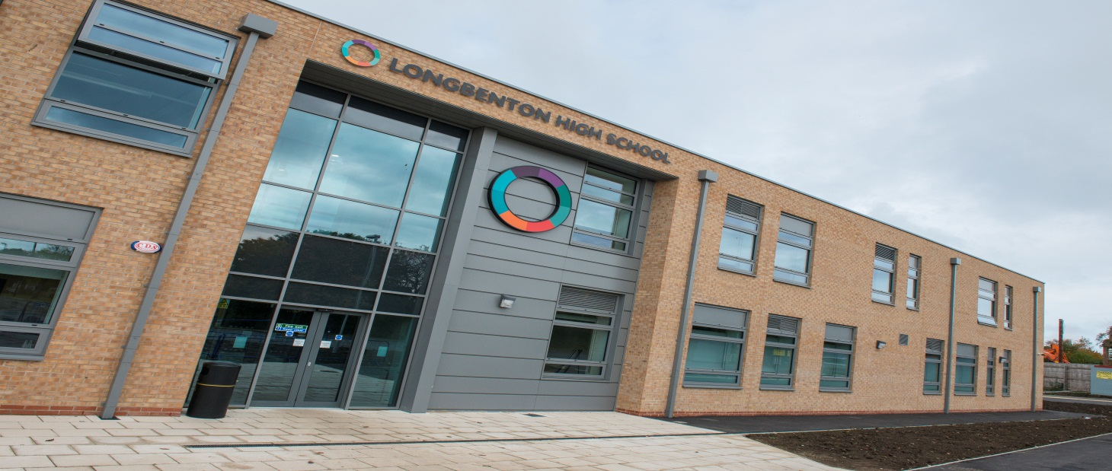

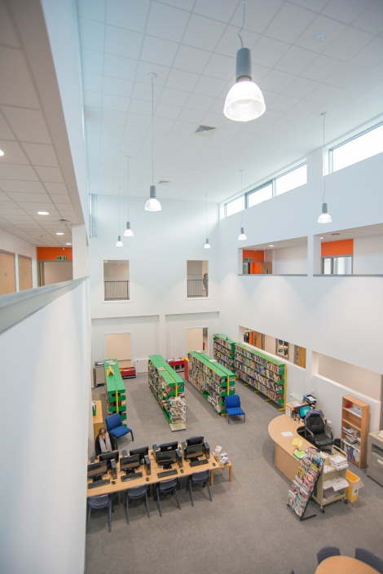
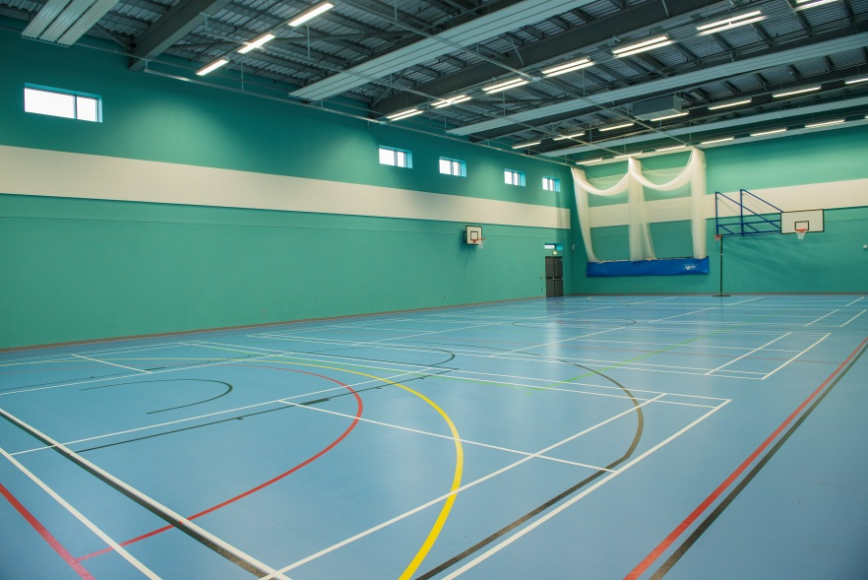
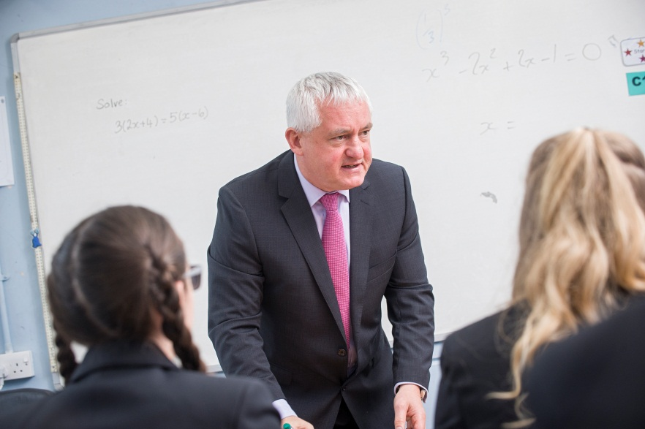

Applicant pack,
Teacher of Design and Technology
Welcome from the Headteacher

Dear Applicant

Thank you for considering the full time permanent post of Teacher of Design and Technology. At Longbenton we have a corridor of our new build devoted to a group of subjects that we call Create. These subjects are very popular at Longbenton both as academic subjects and ones that students enjoy. We are looking for someone who can teach Design and Technology to GCSE standard but who can also contribute to other courses in Create including Food Studies. The post is well suited to both NQTs and those with more experience. Our new school is a fantastic place to work and the facilities in Create are particularly impressive.

These are very exciting times for us and this is a wonderful opportunity for someone to join us at a key point in our development and be part of something innovative, challenging and rewarding. I joined the school myself in September 1998 having worked in two other North Tyneside schools prior to that. I was appointed as Acting Headteacher in January 2015, following the retirement of a long-serving Principal, and that position was made permanent in September 2015. I have stayed at Longbenton so long because the school epitomises my personal ethos towards education: it is inclusive, comprehensive in its intake and a focal point of the local community. I have always been impressed by the quality and commitment of the staff and students at Longbenton and I know that together we can create a bright future for the school.

Making the decision whether to apply for a new post is always challenging on a number of levels. With this in mind I have hope that I have provided you with all of the information that supports you in choosing whether to proceed and make an application. You will be able to see more of us as a school through our website, www.longbenton.org.uk, but if there is additional information that you need in making your application please feel free to get in touch.

OFSTED came to inspect us in May 2015 and rated us as a “good” school, which agreed with our self-evaluation. A copy of the report is available on our website. The timing of the inspection was a positive for us as it allows us to focus on the challenges and opportunities that the move to our new school has given us. We are ambitious both for our young people and for us as a school and want to be the best that we can be in all that we do. I am looking for someone who will earn the respect of a very committed department through their professionalism, hard work, talent and enthusiasm. We are a very cohesive staff who are working together collaboratively to deliver the best education that we can for the young people in the community that we serve. As you would expect, challenge and accountability are integral to what we do but fostering good relationships and treating people decently is important to us too.

Should you choose to apply for this post please pay particular attention to the Person Specification and the Job Description, demonstrating how you meet the requirements, as this will be used in deciding which candidates to shortlist. Electronic applications are preferred and please limit your letter of application to two sides of A4.

I hope that this is the right opportunity for you and good luck with your application.

The closing date is 12 noon on Thursday 30 March 2017 with interviews soon after.

Paul Quinn
Headteacher

INFORMATION ABOUT THE SCHOOL
Longbenton High School is a highly successful community technology college within the Metropolitan Borough of North Tyneside. It is situated adjacent to the City of Newcastle upon Tyne which is the major cultural and sporting centre of the North. It is also close to the borders with Northumberland, with opportunities there to enjoy its unbroken countryside, unspoilt (although cold) beaches and places of historical interest.

The roll of the School is around 900 of whom about 120 are Post 16 students. The catchment area comprises two large municipal post-war housing developments in addition to substantial areas of private housing. Our intake is broadly in-line with national averages in terms of prior attainment, FSM uptake and levels of deprivation. Our students have a positive approach to their learning and OFSTED (May 2015) commented “The behaviour of students is good. Their conduct around the school is good. Students are polite and friendly to each other, and courteous towards visitors.”
Our curriculum has become increasingly personalised. Students in Key Stage 3 follow a core curriculum, although there are options available to students according to their ability and interests. For example, students in Year 9 have option choices around which foundation subjects they follow. Many students start examination work during Year 9 in a variety of courses.

In Key Stage 4, there is again a core curriculum for all students, but students follow different pathways through the curriculum. We look to tailor the curriculum according to the needs of the students. From Year 7 starting points that are typically average, the vast majority of our students make good progress to attain typically above average standards, by the end of Year 11.

The school works closely with 2 other local high schools to provide a wide range of ‘A’ level and other post-16 courses. Students may take all of their courses at Longbenton, or, alternatively, are taken by minibus to study a particular course in one of our partner schools.

We pride ourselves in the quality of our teaching. In our inspection report of May 2015, OFSTED commented on the quality of teaching, saying, “Teaching is mainly good, with some outstanding practice. There is good teaching in school in all subjects.” Students have an earlier finish each Tuesday to allow a weekly two hour CPD programme for teachers. Through our CPD programme, we endeavour to raise further the skills of our teaching staff and this is an on-going whole school priority.
We are a strategic partner in the George Stephenson Teaching School Alliance which allows us to work collaboratively on CPD with other schools and also Newcastle University.

We have a highly developed pastoral system with teaching Year Leaders looking after the overall welfare of students, supported by very committed Form Tutors. The law relating to collective worship is observed and tutors are expected to take tutor assemblies using the assembly theme for the week.

In September 2009, we opened the Melrose Centre for students who have ASD. This is staffed by specialist teachers and learning support assistants. Some of our Melrose Centre students are able to access parts of the mainstream curriculum.

Along with a number of other schools in North Tyneside, the School acquired Trust Status in September 2010. The schools that have acquired trust status have come together to form the North Tyneside Learning Trust in partnership with the Local Authority, higher education institutions, the local FE school and a number of businesses. This will enable our students and staff to benefit from very strong partnerships across North Tyneside.

We pride ourselves in being a very caring community which is able to foster good relationships among its members. Longbenton High School is an exciting place in which to work, with many new developments taking place.

Our new school opened in September 2016 with state of the art facilities. It has been a step change in education for us and our local community. Our old school served us for more than 60 years across a number of different buildings across the site but we are now in one building all under the same roof. It has greatly lifted our sense of community and togetherness. Longbenton High School is a fantastic place to work.



EXAMS / CURRICULUM

KEY STAGE 3 CURRICULUM

All students in Year 7 will study the same subjects, mostly in ability sets. Whatever the nature of the grouping which is in operation, students will be taught at the most appropriate level according to their ability. We are, for example, committed to providing challenging activities for our most able students. Special Needs support is provided where necessary. The curriculum is broad and balanced and reflects the requirements of the National Curriculum.

At the end of Year 8 all students are given an element of choice in their curriculum in Year 9. This means that pupils spend longer on subjects that they enjoy and are doing best in as well as being better prepared for starting GCSE in that area of study should an individual choose to continue in Year 10 and 11.

By Easter of Year 9 all pupils will have completed their Key Stage 3 studies and begun GCSE courses in Maths and Science.

KEY STAGE 4 CURRICULUM

In March of Year 9, students choose their options for Key Stage 4, in most cases leading to GCSE. Pupils are given guidance about courses through a booklet, careers advice and an interview with senior staff. There is a Parents’ Evening for consultation with staff. Every effort is made to ensure that pupils have a balanced curriculum suited to their individual needs. Changes have been made to the choices students are offered to reflect Progress 8 but we do not currently make the EBacc compulsory for anyone.

For some students, for whom it is appropriate, we personalise the curriculum still further to include working with high quality vocational placement providers to broaden their educational experiences beyond the academic. This is complimented by the study of ASDAN courses in Employability Skills as well as the Certificate of Personal Effectiveness course at Level 2.

POST 16 CURRICULUM

We offer a wide range of AS and A2 Levels and Advanced Vocational courses to challenge the large numbers of students wishing to continue in full time education with us after their GCSEs.

Local schools and colleges are increasingly working with each other. We have formed very close links with George Stephenson High School and Seaton Burn Community College with whom we collaborate on post 16 provision.

The great majority of our Sixth Formers’ lessons are delivered here but we also transport students between the schools for jointly delivered courses and have done this very successfully for a number of years now.

PASTORAL STRUCTURE

At Longbenton we have a teaching Year Leader who has key responsibility for the pastoral welfare of their year group. They are led by one of the Assistant Headteachers who has overall responsibility for all issues pastoral including behaviour and attendance.

ENRICHMENT

Our curriculum is supplemented by a wide range of clubs, activities, trips and visits from a wide range of areas including music, drama and sport.

NEW BUILD ZONES

Within our new build, Longbenton High School, the majority of subject areas are housed in different zones:
- communicate – English and MFL
- e-valuate – maths and computing
- explore – history, geography and RSD
- discover – science
- perform – music and drama
- support – SEN, behaviour support
- melrose – our ASD centre
- post 16 – our KS5 area
- create – art, DT, food, textiles, child studies
- active - PE

EXAMS

In general terms we take students who are at about national averages in KS2 and get better than national average results by the end of KS4. We achieve this through good teaching and an effective pastoral system.

5+ A*-C inc En Ma | Percentage
2015 | 60%
2014 | 58%
2013 | 64%

The way that exam results are reported changed in 2016. Our headline figures were:

Basics measure A*-C in both English and Maths 61%.
Progress 8 measure -0.21
Attainment 8 measure 4.68

At post 16 the great majority of our students follow an academic pathway and in 2016,
APS per entry 28.3 with an overall average grade per entry of C-

THE SENIOR LEADERSHIP TEAM

Longbenton’s Leadership Team consists of:
  - Headteacher
  - Deputy Headteacher
  - 3 Assistant Headteachers and the Director of Support Services

The team meets at least twice each week to share updates on developments in all areas and to plan future strategy and events.

THE GOVERNING BODY

The school has a very supportive and hard-working Governing Body. It is quick to recognise the achievements and commitment of staff and offer thanks. It is equally vigilant of areas of concern or difficulty and closely monitors the management of the school through its Committee structure.

DEPARTMENTAL OVERVIEW

Create is a multi-disciplined faculty that offers specialisms in Design and Technology, Food, Textiles, Art and Design, Photography and Child Studies. We are passionate about sharing our collective knowledge and encourage our students to succeed to the best of their creative and technological abilities.

Design and Technology

We take pride in the diversity of our subject and believe that we provide students with a valuable learning experience that will equip them to cope with problem solving situations in their future lives. Design and Technology offers many opportunities for creativity and innovation. We encourage this by enabling students to make design decisions, work independently and constantly challenge themselves.

In all Key Stages Design and Technology pupils combine practical and technological skills with creative thinking to design and make products and systems that meet human needs. They learn to use current technologies and consider the impact of future technological developments. They learn to think creatively and intervene to improve the quality of life, solving problems as individuals and members of a team. Through design and technology pupils develop confidence in using practical skills and become discriminating users of products. They apply their creative thinking, learn to innovate and ultimately solve problems.
A brief outline of the three key stages is given below:
Key Stage 3
Pupils learn and undertake activities that contribute to the achievement of the curriculum aims for all young people: In Years 7, 8 and 9 pupils experience all areas of the Design and Technology Department by completing 4 or 5 design and make tasks over the course of a year. Although the emphasis of the course is on design and practical work, the underpinning theory is also embedded.
Key Stage 4
We offer a 2-year AQA GCSE Design and Technology which will prepare students to participate confidently and successfully in an increasingly technological world. Students will gain awareness and learn from wider influences on Design and Technology including historical, social, cultural, environmental and economic factors. Students will get the opportunity to work creatively when designing and making and apply technical and practical expertise.
This GCSE allows students to study core technical and designing and making principles, including a broad range of design processes, materials techniques and equipment. They will also have the opportunity to study specialist technical principles in greater depth.
Key Stage 5
In KS5 we offer AQA A level Design and Technology: Product Design. This creative and thought-provoking qualification gives students the practical skills, theoretical knowledge and confidence to succeed in a number of careers, especially those in the creative industries. They will investigate historical, social, cultural, environmental and economic influences on design and technology, whilst enjoying opportunities to put their learning in to practice by producing products of their choice. Students will gain a real understanding of what it means to be a designer, alongside the knowledge and skills sought by higher education and employers.

Food Studies and Textiles

We take pride in the diversity of our subject and believe that we provide students with a valuable learning experience that will equip them to cope with problem solving situations in their future lives. Food and Textiles offers many opportunities for creativity and innovation. We encourage this by enabling students to make design decisions, work independently and constantly challenge themselves. To promote our subject throughout the school we also have a Longbenton Bake Off each year which is open to all students. The runners up and the winner of this competition have their recipes served in the school canteen.

A brief outline of the key stages is given below:

Key Stage 3
In Year 7 and Year 8 pupils spend 2/3 of the year in a kitchen learning about food, nutrition and cooking. A lot of the teaching and learning is done through practical work and all of the ingredients are provided by the school. For the remaining 1/3 of the year they work in a specialist textiles classroom designing and making their own “puggly” in Year 7 and a pencil case in Year 8. In Year 9 students have the option to study food for the entire year to prepare them for GCSE.

Key Stage 4
We offer the new 2-year AQA GCSE Food, Preparation and Nutrition course. Students will learn to prepare a range of food products using a wide variety of ingredients. Students have the opportunity to cook and experiment in many lessons as well as studying a range of topics including nutrition, diet, consumer choice, food hygiene and safety, and modifying recipes for specific dietary requirements.

JOB DESCRIPTION

TEACHER OF DT – Main Scale

Reporting to: Curriculum Leaders for Create

- Ethos

- to contribute to the development of the school vison, values and ethos, priorities, targets and plans for improvement
- to have the highest aspirations for students and to be accountable for ensuring the best possible outcomes for students in your classes
- to model professional behaviour and attitudes around the school to ensure that the highest standards of appearance and conduct are met
- contribute to wider school life and the overall vision, values and guiding principles of the school, including through providing opportunities for our students to participate in extra-curricular activities.

- Role Purpose

- to plan for progression across the age and ability range
- to ensure high standards of teaching, assessment and feedback leading to good and outstanding progress and attainment for students in your classes
- to establish a clear framework for positive classroom management based upon appropriate implementation of department and whole school policies

- Teaching and Learning

- to teach challenging, well-organised lessons and sequences of lessons across the age and ability range
- to take responsibility for your own professional development and remain up to date with current practice, undertaking any relevant training

- Administration
- to attend appropriate school meetings
- to contribute to regular departmental meetings and CPD
- to ensure that the school’s administrative procedures are followed
- to ensure that reports to parents are completed to a good standard and are completed punctually
- to comply with policies and procedures relating to child protection, health, safety and security and confidentiality, reporting any concerns

- Student Welfare
- to promote the giving of effective guidance to students in matters relating to the curriculum (e.g. in relation to careers)
- to be accountable for ensuring a secure and positive climate to learning and behaviour of students in your classes, including through the implementation of the school’s Behaviour for Learning programme
- to be a form tutor involving:
- monitoring student progress and achievement
- providing first line support and guidance
- attending school assemblies and conducting tutor group assemblies on the theme of the week
- carrying out administrative tasks relating to the tutor group.

(8) To comply with any other reasonable request from the Headteacher
Person Specification
Teacher of DT Main Scale

 | Essential | Desirable
Experience | To be or have the potential to be an excellent teacher, demonstrating enthusiasm and a commitment to education  Have successful experience of teaching DT across the age and ability range  Able to monitor and evaluate students’ progress and staff performance  Experience of teaching DT at KS3 and KS4  The potential to teach DT successfully at KS4. | The ability to teach KS3 Food Studies.  The potential to be able to teach KS3 Art.
Qualifications | To have Qualified Teacher Status  To have a degree | Prepared to embark upon further training as required.
Practical and Intellectual skills | Be an effective team member  Able to initiate ideas, set own targets and meet own and other people’s deadlines  Have effective communication skills, both written and verbal, to address a variety of groups and individuals including parents  Have very good IT skills  Have the ability to work independently but to consult and liaise regularly  Be approachable and willing to help students both in and outside of lessons  Be interested in children as individuals, in how they learn and be committed to the comprehensive ideal  A strong academic background. | Have evidence of commitment to, and understanding, of collective responsibility
Disposition and Adjustment | Be passionate and dynamic about the subject.  Be resilient, committed, flexible and able to motivate students of all abilities.  Have energy and persistence, tempered with humour.  Able to work closely with a wide range of staff and students and establish and maintain good relationships through good interpersonal skills.  Have commitment to professional development.  Demonstrate personal and professional integrity, modelling values and vision.  Be prepared to participate in extracurricular activities. | An awareness of good practice in identifying individual needs and providing appropriate teaching.
Equal Opportunities | Must have an understanding of and commitment to the school’s equal opportunities policies and procedures.  To be able to demonstrate a commitment to promoting community cohesion. | To have been on an Equal Opportunities training course relevant to education / teaching.

ENHANCED DISCLOSURE
Thank you for your interest in this position at Longbenton. The post that you are applying for involves working with young people. It is therefore exempt from the Rehabilitation of Offenders Act and any offer of employment will be subject to Enhanced Disclosures.

As this post is exempt from the Rehabilitation of Offenders Act, you must declare any convictions, including pending convictions, cautions, reprimands and warning which would otherwise be regarding as “spent” under this Act. Further details will be sought prior to appointment.

An Enhanced Disclosure is carried out by the Criminal Records Bureau and will check criminal records for information on any convictions, cautions, reprimands and warnings held on the Police national Computer and on local police records.

All information on criminal records provided both by you and by the Enhanced Disclosure will be used, stored and disposed of in confidence and in line with the Criminal Records Bureau Code of Practice of Disclosure Information.

If your application is successful, you will receive further information on how to complete the Enhanced Disclosure.

